
Invitational Puzzle Instructions:

Problem:
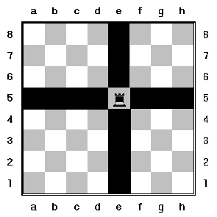
Using only rooks, knights, and bishops on an MxN matrix, find the maximum number of pieces you can place on the board such that no pieces can attack any other piece.

Extra info:
- Rooks can attack up, down, left, and right (see right)
- Bishops can attach diagonals (see right)
- Knights attacks in a “L” so placing a knight in the middle of the board will attack 8 squares (see right)
  - m n
- Your program output should be “m n (row major order representation of the board)”
  - N = none
  - K = knight
  - R = rook
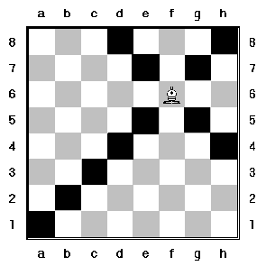
  - B = bishop

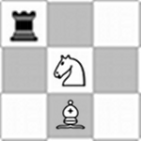
Output for this grid would be:
3 3 RNNNKNNBN

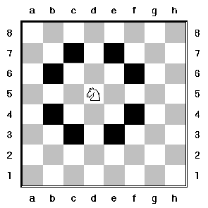
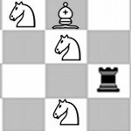
Output for this grid would be:
4 3 KBNNKNNNRNKN

- You can test your output as you go at www.sfmaddogs.com/internproblem.html
- Programs will be judged as a calculation as follows:
  - (Your number/maximum * 70) + (fastest/your speed * 30) for a max of 100.
  - Program with the highest total wins
- Your program will be ran from a Linux terminal

